**Cloud Computing**

**UE19CS352**

**6th Semester, Academic Year 2021-22**

Week #: 3 Exp - AWS S3

Date: 7/3/2022

|  |  |  |
| --- | --- | --- |
| Name :  SUMUKH RAJU BHAT | SRN :  PES1UG19CS519 | Section :  H |

1a.png: Showing S3 bucket created. The name of the buckets should be: <Your SRN>  Eg: pes1201900001

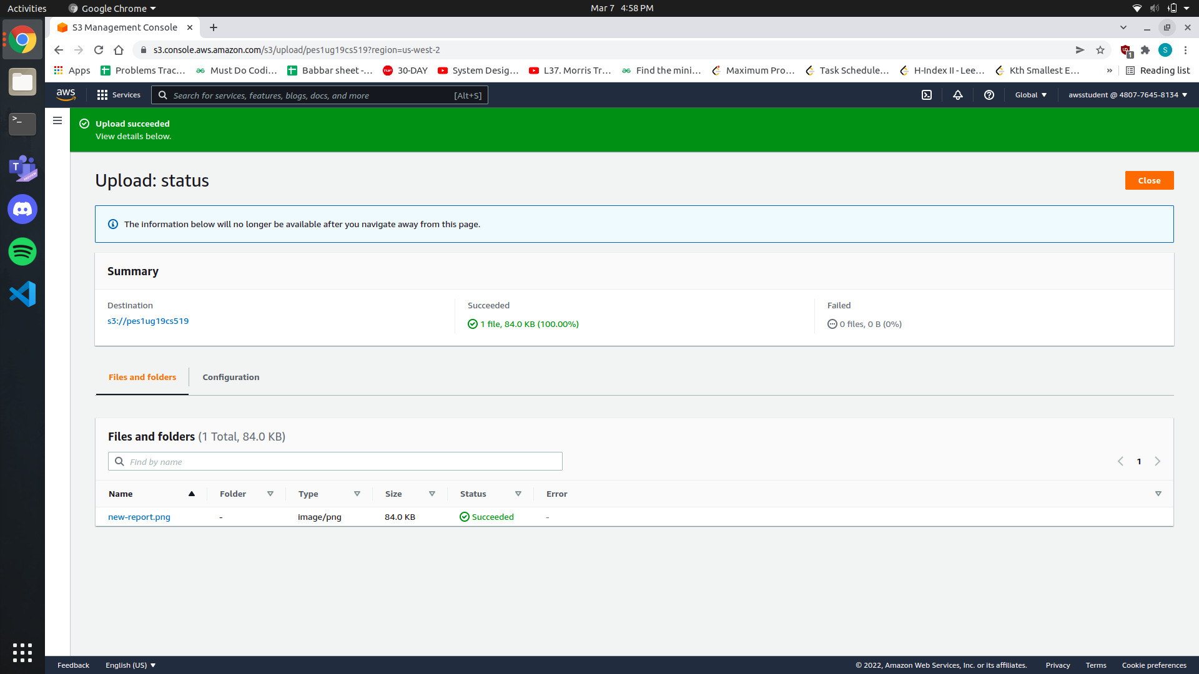

2a.png: Showing the file upload successfully (Include Details).



3a.png: Showing the new-report.png successfully displayed on the browser tab.

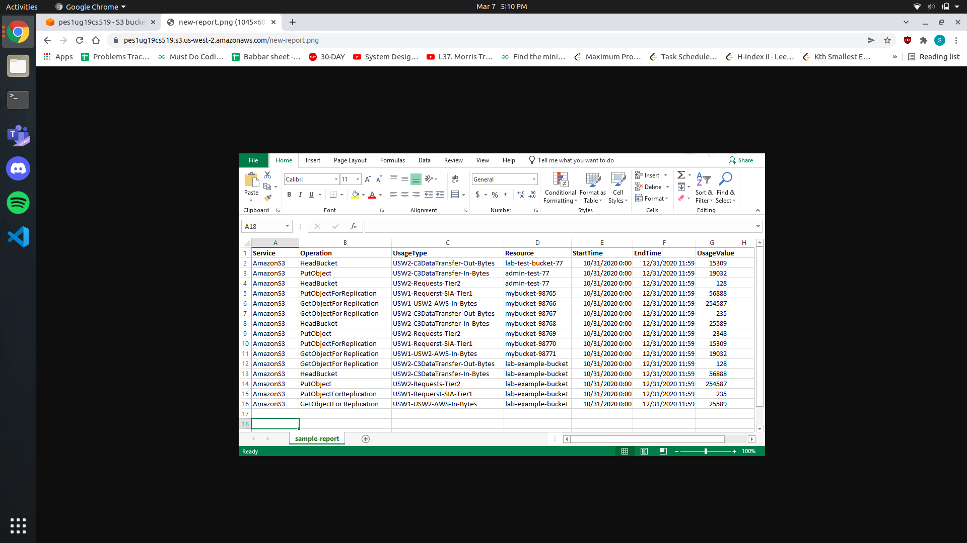

4a.png: Showing all commands executed on the Bastion host including the upload failed error.

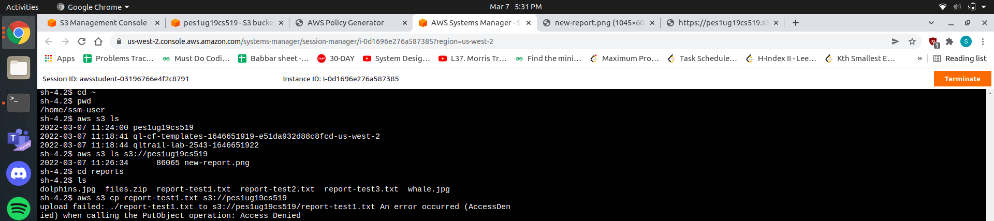

5a.png: Showing all commands executed on the Bastion host including successful retrieval (GetObject) and upload (PutObject).

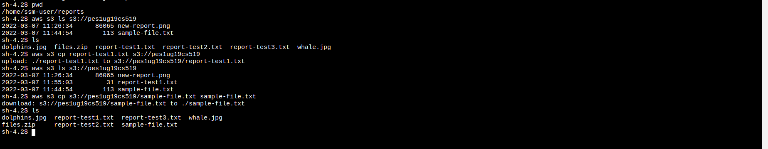

5b.png: Showing the sample-file.txt displayed on the browser tab

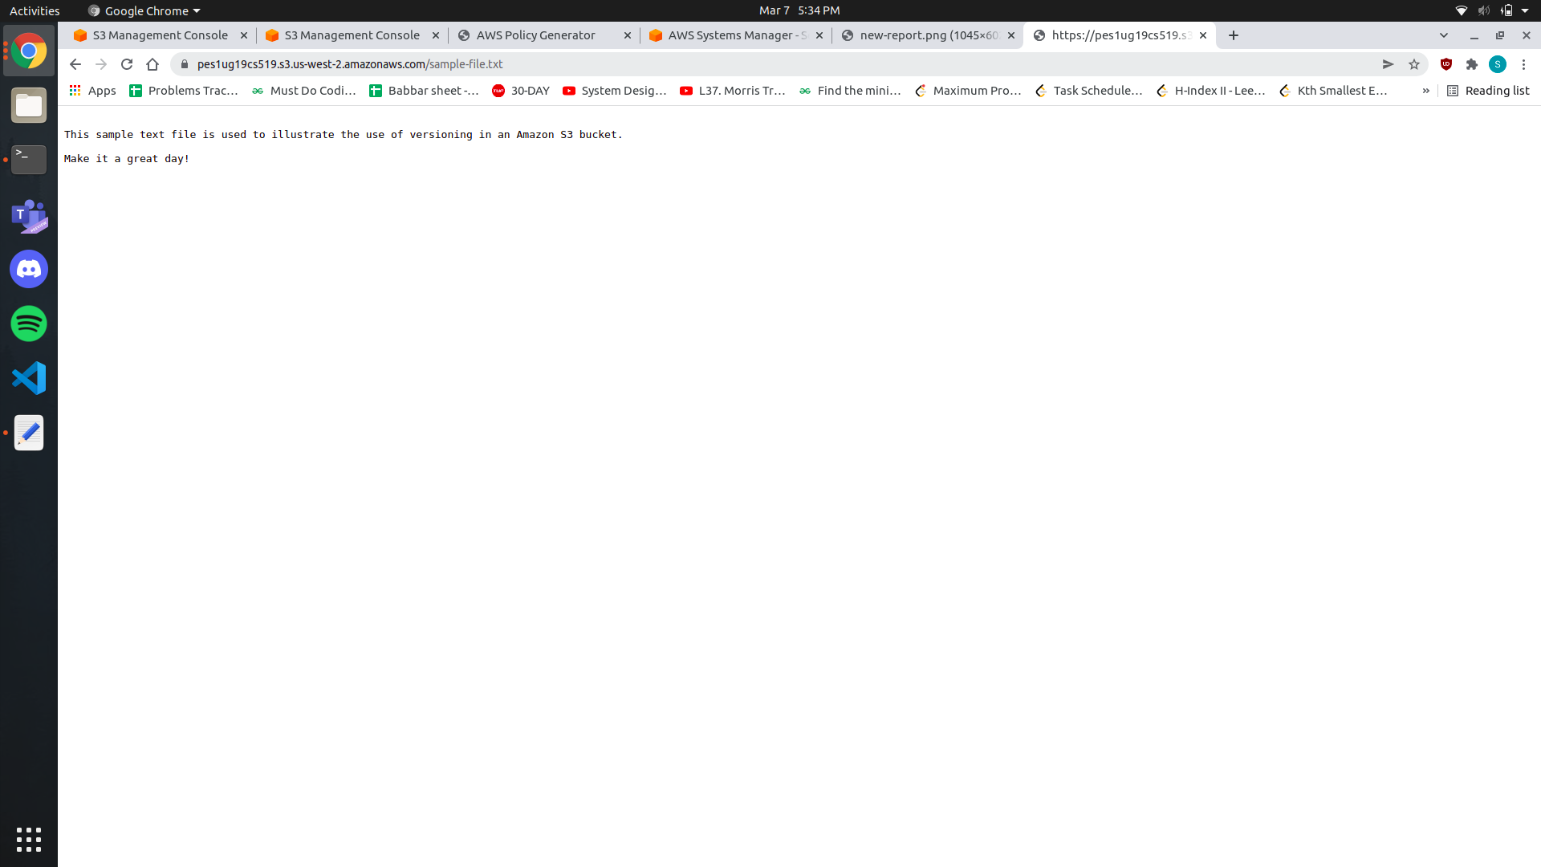

6a.png: Showing the new contents of the sample-file.txt on the browser tab.

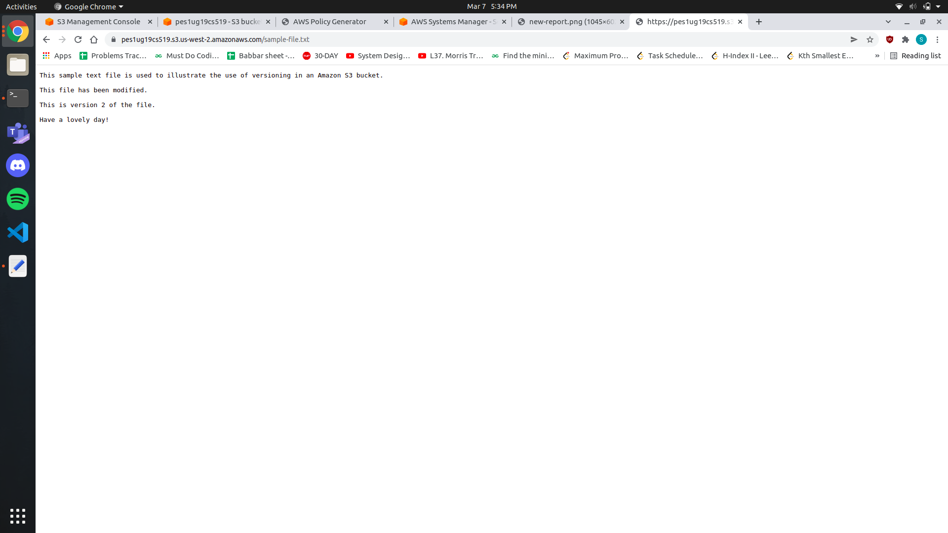

6b.png: Showing the objects tab for the bucket created with the *Show versions* toggle on.

